1. **What is Software?**

= 1) Software is collection of specialized Program or Code which takes input from user and generate desired output.

2) The software is a kind of program that enable a user to perform some specific task or use to operate a computer.

1. **What is Software Testing?**

= 1) Software testing is the process of identifying the **Correctness, Completeness and Quality of the Software Programs.**

The purpose of software testing is to check whether the software **satisfies the specific requirement and expectations of the customer.**

In other words, testing is executing a system or app in order to **find software Bugs, defects or errors**

**\*\*\*\* SDLC (Software development life cycle) \*\*\*\***

* It is End to End development process of software.

There are 6 stages in SDLC

1. Information Gathering/Requirement Gathering
2. Analysis
3. Design
4. Coding
5. Testing
6. Maintenance
7. **Information Gathering :-**

Information gathering is nothing but requirement gathering form customer.

**BA** (Business Analyst) is a person who gather all the requirements from the client to prepare Business Requirement Specifications (**BRS**) document.

1. **Analysis :-**

In the analysis process BA is involve.

BA creates BRS documents into SRS doc. (software requirement specification).

|  |
| --- |
| * SRS is a detailed documentation. * It is also known as FRS (functional requirement specification)   FRS lach aapn SRS mhanto. |

**SRS** divided into different parts

1. Functional flow diagram
2. Functional requirement
3. Use cases
4. Snap shots
5. **Functional Flow Diagram :-**

It is a stepwise representation of software.

It shows relationship between the tasks and gives proper sequence of task.

1. **Functional Requirement :-**

Functional requirement means attributes which are required to complete a specific function.

|  |
| --- |
| Example,  For sign up, its requirements are;  First name  Last name  Mob. No.  Email Id  Password and Submit button |

1. **Use Case :-**

It is a functionality in terms of input >Process and Output

1. **Snap Shot :-**

Snap Shots are visualization of all functionalities before development of product.

Snap shots are created by BA.

Snap shots created by using IRise Software.

Snap shot gives idea to developer that how s\w look like.

1. **Design :-**

There are two types of design.

1. High Level Design:-

It is related to main module.

It is created by design architect

|  |
| --- |
| Eg. Sign up> Log in> Main page |

1. Low level Design:-

It is related to sub module.

It is created by front end developer.

|  |
| --- |
| Eg. Sign up page= fist name, last name, mail id, password |

1. **Coding :-**

Coding means programming

One line is a code and Multiple lines of code is called program.

Developer is responsible for coding.

1. **Testing :-**

Software testing is the process of identifying the **Correctness, Completeness and Quality of the Software Programs.**

The purpose of Software testing is to check whether the software **satisfies the specific requirement and expectations of the customer.**

In other words, testing is executing a system or app in order to **find software Bugs, defects or errors**

1. **Maintenance :-**

It is service provide after delivery of application to the customer.

There are two types –

1. BPO (Business Process Outsourcing)

--- It is non-technical department.

Egg. Customer care, HR department, account team.

1. KPO (Knowledge Process Outsourcing)

--- It is technical department.

Egg. Data analyst team, testing team.

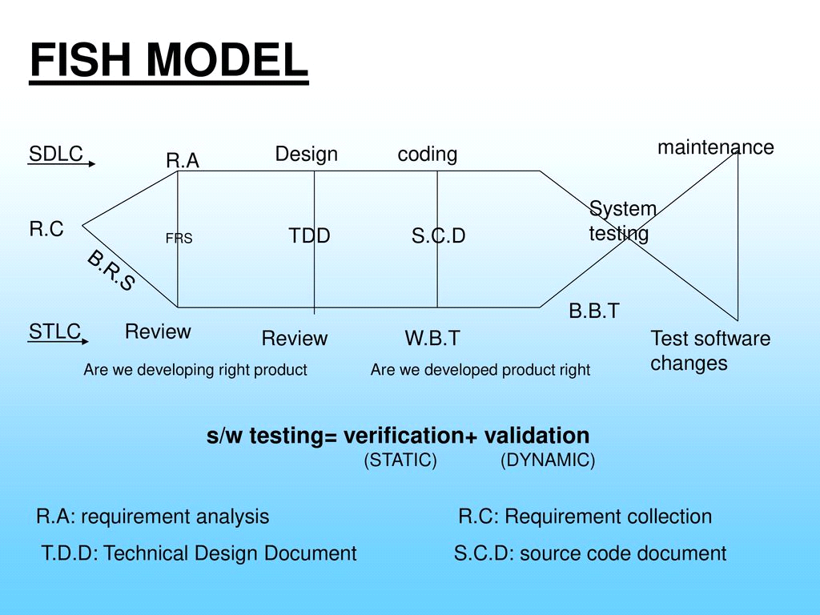

**IT IS AN ADVANCED VERSION OF SOFTWARE DEVELOPMENT LIFE CYCLE (SDLC)**

1. Fish model consists of Two Stages :-

(1) Verification and (2) Validation

Now See,

1) Verification,

It is a quality assurance and also known as Static

Testing.

When BA converts Brs into Srs He\She Just check whether our SRS doc is As per the functionality of BRS doc or not

BA is Responsible for this review

Next is a design phase,

In design phase we just check Our **Design** is as per SRS doc or not

And which is review by Design Architect or front end developer

2) Validation,

It is quality Control Process

It is also known as Dynamic testing

----Testing , Mainatanace

For validation Software tester is responsible.

|  |
| --- |
| **Drawbacks of fish model :-** It is a time consuming process to develop the product. Here we have to wait till the coding for testing. |

**** **Waterfall Model** ****

It is a Step by step Representation of SDLC (Software Development Life Cycle)

This is used in small industry/company/ product base company.

|  |
| --- |
| **Drawbacks of Waterfall model :-** it cannot accommodate changing requirements means we cannot move to the previous stages. |

**** **V Model or V And V Model** ****

* In V-Model Verification and Validation process perform Parallel.

* Development phase mapping with Testing phase.

* To overcome the drawbacks of Fish Model and Waterfall Model we Use V-Model.

|  |  |
| --- | --- |
| **Verification Process** | **Validation Process** |
| 1. Information gathering and analysis –   ** Information Gathering-  Customer and BA involve in this  BA gather all the requirements from customer to creates document which we called BRS doc  ** Analysis-  In this stage BA converts BRS doc into SRS doc. | 1. Assessment of development phase –   In this phase project manager is involved and strategy of the testing will be decided here by project manager. Also which method we are going to use for testing will be decided.   1. Test plan preparation –   Here project manager will prepared test team. Means he\she distribute work to the team. |

|  |  |
| --- | --- |
| **Verification Process** | **Validation Process** |
| 1. Design and Coding   ** Design –  There are two types of design  A] High Level Design-  - It is related to Main Module.  Egg. Signup page, Log in page, Home page.  - It is developed by Design Architecture.  B] Low Level Design-  - It is related to Sub Modules.  Egg. For main module sign up page:- first name, last name, mail id, mo.no. etc | 1. Design Phase Testing   - It is related to Developer.  - Here developer do WBT (white bx testing)\Unit Testing  - and check only positive test scenario.  B) Program Phase Testing  - It is related to testing team\tester.  - Here tester do black box testing means check positive as well as negative scenario.   1. Test Case Design   1) Test Scenario = What to test?  2) Test Case = How to test?  * Test Case depends upon Test Scenario. |
| **Verification Process** | **Validation Process** |
| 1. Integaration (Build Installation)   -In this testing developer merge the old module into the new module.  - after that they again perform wbt/positive testing/unit testing. | 1. Sanity Testing   This is the first type of testing which is perform by tester.  In the sanity testing, tester just check whether our module is able to do testing or not.  And also here we check basic and core functionality.   1. Functional Testing & Sys Testing   In this process we check top to bottom functionality of module/build/software as per SRS document and also check completeness and correctness of the s/w as per customer requirement.   1. UAT (User Acceptance Testing)  |  | | --- | | Testing Phase Environment ==  1.DIT (Development Integration Testing)  म्हंजे डेव्हलपर ने जे इंटिग्रेशन च कॉम्बाइन मॉड्युल तयार केलेल अहे त्याचि to टेस्टिंग krto (wbt)  - Developer involved in it.  2.SIT (System & Integration Testing)  - Tester involved in it.  यात आपन sanity testing आणि functional and system testing perfom krto.  After Successful completion of Sys testing & Functional testing product moved to the UAT.  C. UAT (User Acceptance Testing)  - User & Tester involved in this testing. | |

|  |  |
| --- | --- |
|  | 1. Documentation   - It is report of testing.  - Each tester has its own test report.  - Whenever tester perform testing on the module he/she create document of testing.  The report involve following points,   1. Name of the Module 2. How many test scenarios? 3. How many test cases? 4. Passed 5. Failed |

|  |  |
| --- | --- |
| **Verification Process** | **Validation Process** |
| 1. Maintenance   --- It is service provide after delivery of application to the customer.  There are two types –   1. BPO (Business Process Outsourcing)   --- It is non-technical department.  Egg. Customer care, HR department, account team.   1. KPO (Knowledge Process Outsourcing)   --- It is technical department.  Egg. Data analyst team, testing team. | 1. – (1) DRE (Defect Removal Efficiency)   --- It is the process of calculation at which level tester did testing.  --- Tester efficiency will be calculated here,  Formula for calculate DRE,  DRE = A/A+B  ( A= Defect found by tester, B= Defect found by user/customer)   * 1. to 1 = Good Testing   Below 0.8 = Bad Testing  -(2) RFC (Request For Change)  --- In V-Model customer can request for change at any stage of the SDLC.  --- For this changes customer need to pay some extra amount.  (RFC/ CR/ MR = Request for change/ Change request/ Modification request).   * (3) Regression Testing   It is the process of checking the any adverse effect on module or application due to new changes or bug fixes. |

**TRM (Test Requirement Matrix) =**

It is nothing but mapping between development phase and testing factor.

Means mapping between requirements and test cases.

**Agile Model/Architect**

**\*\* What is Agile model?**

= 1. It is a module driven methodology. (It means here we do Module wise delivery of the product)

2. And also value driven methodology. (Customer is high priority in it. Here we do customer oriented things.)

3. In agile model customer can request for change at any stage of software development life cycle without paying extra amount.

4. Standard Sprint duration (time duration) for agile model is One Month.

5. Agile methodology used in serviced based companies.

**\*\* Agile Architecture –**

1. **Stake Holder**

--- It is a Customer/User.

--- It is the top most body of the company.

--- Customer can request for change at any stage of software development life cycle without paying extra amount.

--- They have bunch of requirements in terms of User Stories (Requirements are Nothing but User Stories).

1. **Project Owner/Product Owner** (सोप्या भाषेत He is a BA पण BA म्हणायचं नाही)

--- Project owner/Product owner gather all the requirement (User Stories) from the Stake Holder and create Product Backlog.

1. **Product Backlog**

--- Project/Product Backlogs are the total requirements for the whole project. Means it includes all the requirements of all module.

1. **Sprint Planning**

--- In agile we do module wise delivery of the product.

---So, Sprint planning is the Process of Sorting User Stories To Development of the Module. Here we select those user stories which we will be developing in next sprint.

**Involvement In Sprint Planning Meeting-**

1. Scrum Master (Chair Person, In simple way he is a Leader of an agile team)
2. Project Owner/Product Owner
3. Development Team
4. Testing Team.

**Agenda Of Spring Planning Meeting :-** Selection of user stories for the next Sprint.

He fkt aaplya knowelege purpose sathi ahe….

* Factors for selection of user stories :-

1. Knowledge

– Team should have domain knowledge.

1. Effort

– How many Resources / People are involve in project.

1. Complexity

– Estimation of time, Cost, Resources. (yaat aapn Project la kiti kharch lagnar ahe he sangto)

1. **Sprint Backlog**

--- It is created by Project Owner / Product Owner.

--- It contains sorted user stories which we decided in sprint planning meeting. Having detailed information about particular User Story / Sprint.

* User Stories :-

--- It is Requirement of customer, which is sorted in sprint planning meeting.

* Description Criteria :-

--- Means as a customer what he/she want to do. (What user exactly want)

* Acceptance Criteria :- it is nothing but scenario

--- When the scenario is correct the system generate correct output, Otherwise it shows failure msg.

1. **Test Case Design (इथ आपन Testing सुरु कर्नार आहोत)**

There are two things in it, first test scenario and second test case

1) Test Scenario = means What to test? It is also called “Test condition” or “Test Possibility”

2) Test Case = How to test?

* Test Case depends upon Test Scenario.

Once Sprint backlog ready then Project owner sends it to Development Team and Testing Team.

-Then Developer starts their coding work and same time tester start test case design.

-Test cases means multiple steps involved while testing

-Test cases are mapped with sorted user stories.

And tester is responsible for test case design.

* **Advantages of Agile Methodology**

1. **Check Point**

(It is an essential part of the testing process.)

Sinup page 🡺 Login page 🡺 Main page 🡺 Logout page=====🡺 FB app.

-Example: Consider there are four module developed M1, M2, M3, and M4... -Then Check point will be added between the two module means Between M1 and M2, Between M2 and M3...same for M3 and M4 –

If at the time of production or after production error occurred in application or Module then tester do not need to test all modules instead of that tester can just test Check point provided between Module M1 and M2 if error not present then test other check point provided between M2 and M3.

-If tester found issue between M2 and M3 then tester will raise the same check point to Developer.

-Then developer just finds out root cause for Check point where issue occurred and fixed issue.

But in V-Model Developer need to check all modules codes that called Post Mortem Testing. It is very time consuming Process.

-For testing Check point Tester Used "AVAS" Tool.

-Check point save time of both Tester and Developer.

1. **Scrum Meeting**

* It is a daily standup meeting.
* Its duration is 15 to 30 minutes on daily basis.
* Involvement --- Scrum Master, Product / Project Owner, Development Team, Testing Team.
* Scrum master is chairperson for this meeting.

Scrum master asks 3 things in this meeting—

1. What we did yesterday?
2. What we are going to do today?
3. What are the road block or any issue while working on project.

1. **Implementation Of Automation**

* We can implement Automation in Agile Methodology.
* Automation is time saving technic.
* Advantages of Automation :-

1. Less resources required
2. Less resources means less cost
3. High accuracy
4. Less human errors
5. Time saving testing method
6. Sprint wise delivery

* **Scrum Framework:**

It is a framework used to implementation of the agile software development methodology.

Scum is used where project requirement continuously changing.

In scrum framework Project is divided into small no. of requirements means sprints, by using scrum framework sprint wise delivery possible.

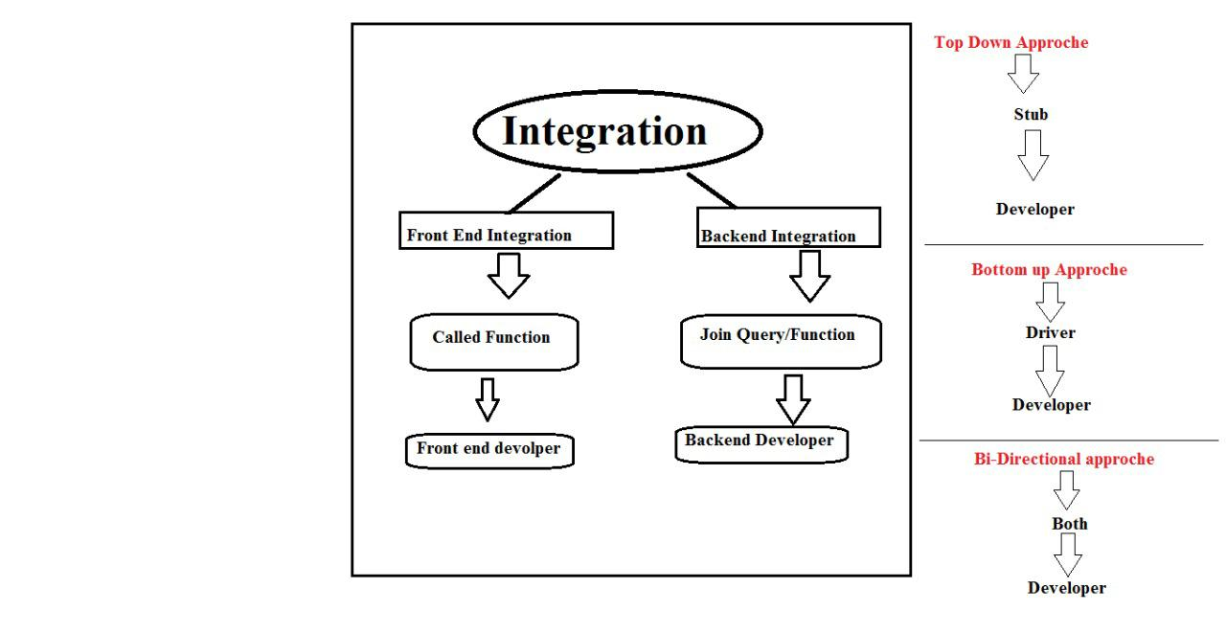

* + - * **Integration Testing :-**

It is Developer task

In this testing developer merge the old module into the new module.

Developers develop no. of modules separately and adding in one application it is called integration.

**\*\* There are two types of integration :-**

1. Front End Integration (FEI) -----

It is related to GUI (graphical user interface) or UI (User Interface)

Here Front end developer connects two modules using “Called” Function.

1. Back End Integration (BEI) -----

It is related to data bases.

Here developer connect two or more tables in data bases using “JOIN QUERY” .

Integration testing it is the process of checking correctness and completeness of the flow of functionality whenever integration of module completed.

**Whenever Integration of modules done then Integration testing start by Developer for that he use three approaches**

**\*\* Testing Approaches :-**

1. Top Down approach
2. Bottom Up approach
3. Bi-directional approach/Hybrid Approach
4. Top Down Approach :-

When Dev have main module but don’t have sub module (Next Module) in that condition developer use top down approach.

At that time developer create dummy module Called “STUB”.

STUB is created by XML (Extensible Markup Language) Programming Language.

STUB is checked by using SOAP UI tool.

1. Bottom Up Approach :-

When Dev have sub module but don’t have main module in that condition dev use Bottom up approach.

At that time developer create dummy module Called “Driver”.

Driver is created by XML (Extensible Markup Language) Programming Language.

1. Bi-directional approach/Hybrid Approach :-

It is combination of Top Down and Bottom Up Approach.

-For Example: If developer developed Login Page and he have to check functionality with Sign UP and Home page that condition developer create dummy module of Sign up Page by using Driver and dummy module of Home page by using Stub.

**Sanity Testing**

* This is the first type of testing which is perform by tester.
* In the sanity testing, tester just check whether our module is able to do testing or not.
* It is also called as zero level testing, Build verification testing and Tester acceptance testing.
* In sanity testing we do mainly testing for:

1. Basic and core functionality
2. Tab validation
3. Link validation
4. Page validation
5. GUI validation
6. **Basic and core functionality:**

In this, Tester tests Buttons, Icons from which user proceed to next stage.

Egg. Submit button, sign up button, login button (We check it is clickable or not).

1. **Tab Validation:**

Tabs are nothing but text boxes, in which we enter the values.

Egg. First name, last name, Email Id, Mobile no.

--Here we check Tabs are enable or not.

Whenever we entered any value in text box through keyboard then those value, symbol, number should be enter in the text box.

1. **Link Validation:**

In this process sequence of interlink pages get tested.

Here we check interlink is active or not, clickable or not.

Egg. Forget password, learn more.

1. **Page Validation:**

It is also called Navigation Testing.

In this testing, when we clicked on next and back button then it should be navigate front and back page respectively.

Page Scroll up or not, Page Scroll down or not.

1. **GUI (Graphical User Interface) Validation:**

This is validation of visualization.

In this process tester check whether the pages displayed correctly or not, image should be clear not blur, Page should be full loaded.

* + - * When Interviewer asked what is difference between sanity and smoke testing then just tell them-

Actually there are no more difference between sanity testing and smoke testing but in our company we are using sanity testing so I have good idea about it but I have only theoretical knowledge about smoke testing should I explain:-

It is an advanced version of sanity testing, here we do sanity testing + package validation.

Package validation means if any error found in program or module then developer easily find out from which package the error is coming.

**Functional Testing**

When sanity testing successfully completed then we start functional testing.

It is also called system and functional testing.

In this process we check top to bottom functionality of module/build/software as per Sprint backlog and also check completeness and correctness of the s/w as per customer requirement.

In this testing we execute test cases written by us.

Also we check internal functionalities means we check different coverages-

1. Behavioural Coverage
2. Input Domain Coverage
3. Error Handling Coverage
4. Service Level Coverage
5. Calculation Based Coverage
6. Back End Coverage

(**Test case lihinyasathi aapn coverage vaprat asto** म्हंजे **ya aadharavr test case lihito)**

1. **Behavioural Coverage:-**

Here we check Property and Behaviour of the object.

For egg. Text Box

Property:- It should accept user input.

Behaviour :- When we clicked on text box then it should focusable when remove focus it should un-focus.

Another egg. Dropdown Box

Property :- It should hidden list

Behaviour :- Show list or hide list.

1. **Input Domain Coverage:-**

There are two test design techniques

BVA and ECP

In input domain coverage we maintain BVA and ECP.

BVA (Boundary value analysis) = BVA check size of the input.

ECP (Equivalence Class Partition) = ECP check data type of the input. (Means valid and invalid data).

For egg. Mobile Number Field

BVA: Min 10 digit and Max 10 digit (If you put 9 digit in that field it should not be accepted)

ECP: Valid and invalid input

Valid input for mobile no. field is between 0-9 numbers

Invalid field means, alphabets like A-Z, symbols, space.

1. **Error Handling Coverage:-**

Here we check whether system generate error message or not.

When we entered invalid data in field the system should be generate error message.

Egg. Mobile No. Field : If we entered less and more than 10 digit in mobile no. field then system generated message--- “ please enter valid Mobile Number”

1. **Back End Coverage:-**

The backend of any software is data base.

Here we check whether entered data stored successfully in data base or not.

And also check whether data get fetch from data base or not.

Egg. If we filled online examination form by adding all required information then clicked on Submit button.

--- Then all data saves in data base. Then we check we are able to log in or not by using user name and password.

--- We can also fetch specific person/candidate information from data base.

1. **Service Level Coverage:-**

Here we check working of system as per functional flow diagram or not.

In this we check sequentially of functional module.

-Ex: If you are filling online examination form

-Then, 1) Personal Information Detail 2) Contact Details 3) Academic Details 4) Banking/Payment details 5) Submit

-In above example once one stage completed then system should allow to next stage.

1. **Calculation Based Coverage:-**

In this we check arithmetic operations.

Addition, subtraction, multiplication, division.

**Non-Functional Testing**

It is the process of checking the outer correctness and completeness of the software as per customer requirement.

1. **Recovery Testing:-**

It is the process of checking whether application is able to recover from abnormal condition to normal condition.

It is also called Reliability Testing.

Recovery requirements are given by customer.

Customer can give requirements that application should recover from specific point or from start point.

Example: Suppose we Downloading large music file and suddenly internet connection lost, then downloading paused, When Internet connection return back then System should start downloading of music from paused position. (This is customer Requirement) -If Music downloading start from starting then there will customer data lost.

1. **Compatibility Testing:-**

It is also called Portability Testing.

Here we check our applications how perform on different platforms (Browsers, Operating System).

-Browsers: Chrome, Mozilla Firefox, IE, Safari

-Operating System : Windows, Linux, Mac

There are two types of compatibility testing:

1. Forward Compatibility Testing
2. Backward Compatibility Testing
   * + - **Forward Compatibility Testing:-**

If build/application is correct but browser/operating system do not working properly then it is forward compatibility testing.

And we found less errors in this testing.

* + - * **Backward Compatibility Testing:-**

If browser/operating system is okay but build/application do not working properly then it is Backward compatibility testing.

We found maximum errors in this testing.

In compatibility testing I am involve in Browser compatibility testing.

Browser compatibility testing have two types:-

1. **Cross browser compatibility testing:-**

In this process tester check application on different browsers.

Egg. Chrome, Mozilla Firefox, Opera mini, edge, EI, Safari…

1. **Version Comparison compatibility testing:-**

In this process tester check application on different version of same browser.

Egg. Chrome: 94.0, 94.01, 94.02…

1. **Inter System Testing:-**

It is the process of checking whether our application able to share resources with other application or not.

--Means we just check our application share data with other application or not.

(mhanje he third party type ast)

Egg. Airtel Customer Recharge with Phone Pay Application

-We enter our mobile number in Phone Pay for plan search then clicked on Search button...Then you will get plans in result. so here Airtel server share data with Phone Pay server.

1. **Globalization Testing:-**

It is the process of checking whether application is support different languages or not.

There are 3 types of testing in it….

1. **Localization Testing:-**

Here we check whether our application supports local languages or not…

Egg. (Suppose we are developing application for indian country okay so what we do…? We just check our application is support local indian languages or not …languages like marathi, telgu, tamil, gujrati and others like that).

1. **Internationalization Testing:-**

Here we check whether our application supports official languages of different countries.

Egg. Hindi, Chinese, French, Japanese, and others (Thodkyat kay rashtriya bhasha veg-veglya deshanchi support krto ki nahi te baghto)

1. **Globalization Testing:-**

Here we check whether our application supports Global English Language.

It also called as G11N Testing.

---- Whenever user change language, so at that time language should be change but Numbers should be in English. (It is user requirement)

* **Sanitation Testing:-**

--- It is the process checking is there any extra feature added by developer or not which is not mentioned in customer requirement.

--- It is also known as Garbage Testing.

--- When we found any extra feature , so we create a bug ticket for that and assign to developer.

--- After that we discuss on that feature in daily Stand-up meeting.

--- Then project owner contact to Customer and ask about the extra feature.

--- If customer wants that extra feature, so for that customer need to pay extra amount… if customer don’t want then developer need to remove this extra feature.

* **Re-Testing:-**

It is the process of checking module with multiple test data.

We perform re-testing two times………..

1.. Suppose we found any defect then before creating bug ticket we retest that defect with multiple data.

2.. After developer solved defect and assigned to us. Then again we retest that application to check whether defect still present or not.

***What is the difference between re-testing and regression testint?

---- So in Re-testing we just retest the raised bug resolved or not (Means here we just check raised issue)

--- But in Regression testing we check adverse effect on module or application due to new changes or bug fixes. (Means here we check all modules)

* **UAT Testing (User Acceptance Testing) :-**

---UAT starts after successfully completion of SIT.

---It is performed by the end user or client to accept the software system before moving the application to the production environment.

--- So, It is the process of collecting feedback from customer.

--- User, Tester and Developer all are involve in it.

---It is also known as end to end testing.

Process of UAT :-

1. Testing team share Desktop to user by using Q-Messenger.
2. Then, Tester starts test case execution in front of user.
3. When one test case execution completed, we clear cache, cookies and history then move to the next test case execution.
4. After one test case execution completed then we get session ID from the tool. Session ID contains all the actions performed by the tester.
5. We use this session ID on “Bharat Mantri or AVAS tool” for searching log file.
6. Then we get log file which is available in .txt format.
7. Then tester send this log file to development team by using Q-Messenger
8. When the all process successfully done then our product is ready to production

But whether the product should move to production or not its depend upon customer.

There are two types in UAT,

**Alpha Testing:-**

Involvement in Alpha Testing--- User, Development Team, Tester Team.

It is conducted under control environment. (Because Tester and User both are present)

In our organization we follow alpha testing. (because we conduct it under control environment)

--- Alpha testing used in serviced based companies.

Service based com. Egg. Phonepay, icici , swiggy

**Beta Testing:-**

There is no involvement of user in Beta testing.

* **Production Issue/Hot Fix:-**

--If customer found any defect in product after production that is called production issue or Hot fix

--At that condition, Higher authority is responsible. (Means QA or Team Lead)

Procedure for solving Production Issue:-

-- 1) If customer found any defect then raised issue to Customer Care of the company.

2) As we know customer care don’t have knowledge about that issue so they raised issue to the technical team.

Technical team means…. Project owner, development team, Testing team and scrum master.

3) Then product owner assign issue to the developer.

4) Then developer find out the root cause and solve issue.

5) After fixing issue developer send it to testing team for testing.

6) Then tester test the issue is it present or not. If issue resolved then we pass for production.

* **Priority & Severity:-**
* **Severity:**

It is always related to functionality of the application.

Severity means how much our application is getting affected because of the defect.

--Severity will be decided by Testing team because tester knew about the seriousness of defect on functionality of product.

* **Priority:**

Priority is considered from the customer’s point of view.

In simple priority means which defect should be fix first.

Priority set by the product owner/customer.

* **Testing Terminologies:-**
* **Monkey Testing:-**

It is also called Speed Testing.

---When we have no of test cases for execution but don’t have sufficient time at that condition we perform monkey testing.

Here we only execute higher priority test cases.

If time left then we test Medium and Low priority test cases.

* **Exploratory Testing:-**

When you don’t know about application but you have test cases, test case data, Sprint backlog means all type of requirements at that time we perform Exploratory testing.

--It is all about exploring, finding out about the software means what it does, what works, what doesn’t work.

* **Ad-hoc Testing:-**

--It is experienced based testing technic.

When you have everything but don’t have Test Data… everything means you have time, knowledge about application, test cases….but don’t have test data that time you perform Ad-hoc testing.

--- Tester carried out it on the basis of previous knowledge or previous experienced.

--Ad hoc testing is done randomly.

**What are the Roles and Responsibility of Test Engineer?**

**1) User Story Analysis**

**2) Test Scenario Identification**

**3) Test Case Design**

**4) Test Case Review**

**5) Test Case Execution (Perform Functional & non-Functional Testing)**

**6) Test Summary Report**

**7) Defect Logging (Create bug ticket) & reporting (Assign to specific developer)**

**8) Sometimes we have to do client interaction**

**9) Estimation of Testing (Means how much time require for testing we give in Story Point)**

**10) Carrying out regression testing & retesting after defect fix.**